**Requirement Gathering and Analysis Phase**

**Technology Stack (Architecture & Stack)**

|  |  |
| --- | --- |
| Date | 04-07-24 |
| Team ID | SWTID1719938063 |
| Project Name | ShopEZ: E-Commerce Application |
| Maximum Marks | 3 Marks |

**Technical Architecture:**

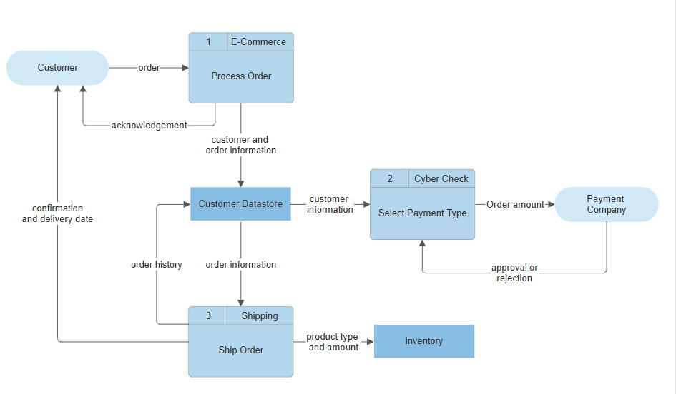

**Table-1 : Components & Technologies:**

|  |  |  |  |
| --- | --- | --- | --- |
| **S.No** | **Component** | **Description** | **Technology** |
|  | User Interface | How user interacts with application | HTML, CSS, JavaScript |
|  | Frontend Framework | Framework to build the frontend of the application | React.js |
|  | Backend Framework | Framework to build the backend of the application | Node.js, Express.js |
|  | Database | Storage of application data | MongoDB |
|  | Cloud Database | Database Service on Cloud | MongoDB Atlas |
|  | File Storage | Storage of files and media | Amazon S3 |
|  | Payment Gateway | Integration for handling payments | Stripe, PayPal |
|  | Analytics and Reporting | Tracking and reporting user behavior and sales | Google Analytics |
|  | Performance Optimization | Enhancements to manage high traffic and reduce latency | CDN (Cloudflare), Caching (Redis) |

**Table-2: Application Characteristics:**

| **S.No** | **Characteristics** | **Description** | **Technology** |
| --- | --- | --- | --- |
|  | Open-Source Frameworks | List the open-source frameworks used | MERN Stack |
|  | Security Implementations | Implementation of security measures such as encryption and access controls | SSL/TLS, OAuth 2.0 |
|  | Scalable Architecture | Scalability ensured through modular architecture Docker, Nginx | Docker, Nginx |
|  | Availability | High availability achieved via load balancers | Load balancers, Distributed servers, Nginx |
|  | Performance | Enhancements to manage high traffic and reduce latency | CDN (Cloudflare), Caching (Redis) |